TASK 2: VISITOR MANAGEMENT SYSTEM
Code :
class Visitor:
def __init__(self):
self.count=0
self.visito_Name=""
self.visito_Time=""

def check_In(self):
if self.count==0:
self.count+=1
print("\n=================Visitor Check_In =================")
self.visito_Id=input("Enter Visitor ID : ")
self.visito_Name=input("Enter Visitor Name : ")
self.visito_Complay=input("Enter Companay Name : ")
self.visito_Num=input("Enter Mobile Number : ")
self.visito_Meet=input("Person to Meet : ")
self.visito_Dept=input("Department : ")
self.visito_Purpose=input("Perpose of visit : ")
self.visito_Time=int(input("Entry Time (Hour 0-23) : "))
print("Visitor Checked In Successfully")
print("Welcome,",self.visito_Name)
return self.visito_Time
else :
print("You have already cheacked In...")
def check_out(self):
if self.count==1:
print("\n=================Visitor Check_Out =================")
self.exit=int(input("Enter the exit time :"))
if self.exit<self.visito_Time:
print("exit time must be more then cheak in time...!")

else:
print("exit Time:",abs(self.exit-self.visito_Time))

print("\n================= Visitor Summary =================")
print("Visitor ID :", self.visito_Id)
print("Visitor Name :", self.visito_Name)
print("Company :", self.visito_Complay)
print("Mobile :", self.visito_Num)
print("Person to Meet :", self.visito_Meet)
print("Department :", self.visito_Dept)
print("Purpose :", self.visito_Purpose)
print("Entry Time :", self.visito_Time)
print("Exit Time :", self.exit)
print("Visit Duration :", abs(self.exit-self.visito_Time), "Hours")
self.count=0
else:
print("First Check_In..............!")

def guidline(self):
print("\n========== Visitor Guidelines ==========")
print("1. Wear your Visitor ID Card.")
print("2. Photography is not allowed.")
print("3. Follow company security rules.")
print("4. Smoking is prohibited.")
print("5. Return Visitor Pass before leaving.")
print("6. Report to Reception while exiting.")

start=True
check_in=Visitor()
while(start):
print("\n==========================================")
print("KAIZENTRIX GLOBAL SOLUTIONS")
print("Corparate Visitor Management System")
print("==========================================")
print("1. Visitor Chick_In")
print("3. Visitor Chick_Out")
print("3. Visitor Guidline")
print("4. Exit")
choice=int(input("Enter your Choice : "))

if choice==1:
check_in.check_In()
elif choice==2:
check_in.check_out()
elif choice==3:
check_in.guidline()
elif choice==4:
start=False
else:
print("Choose the correct option...!")

OUTPUT
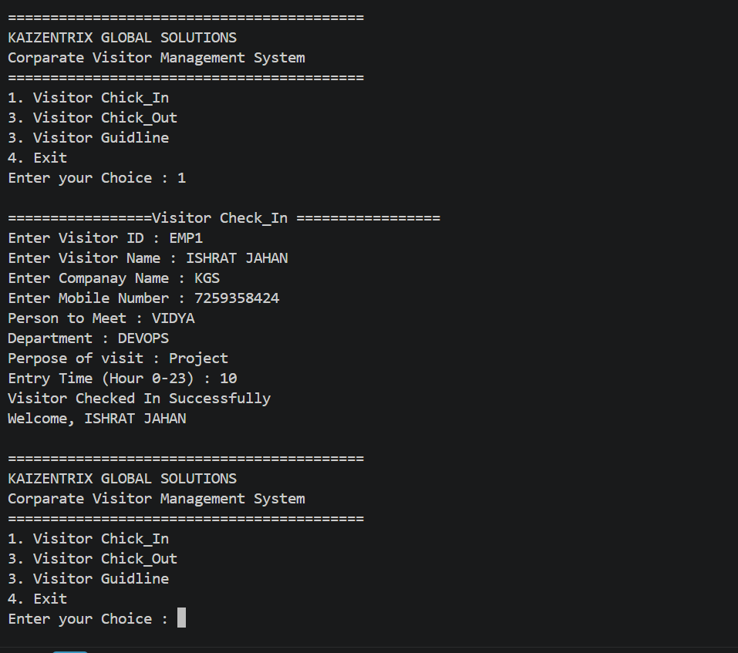
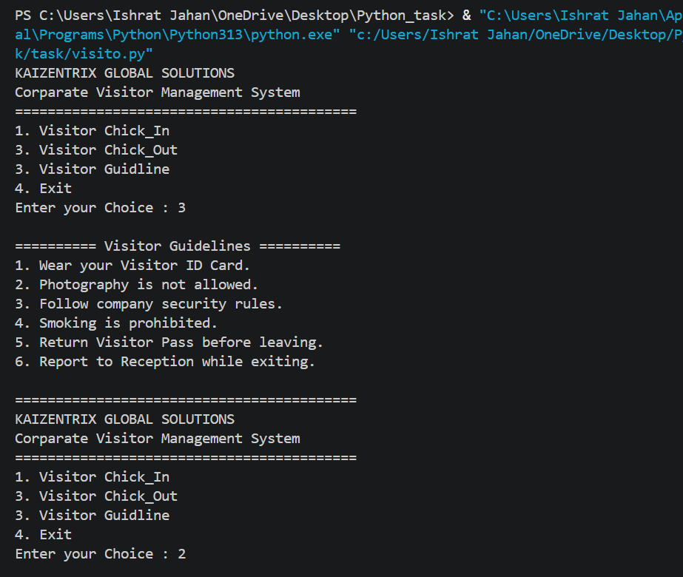
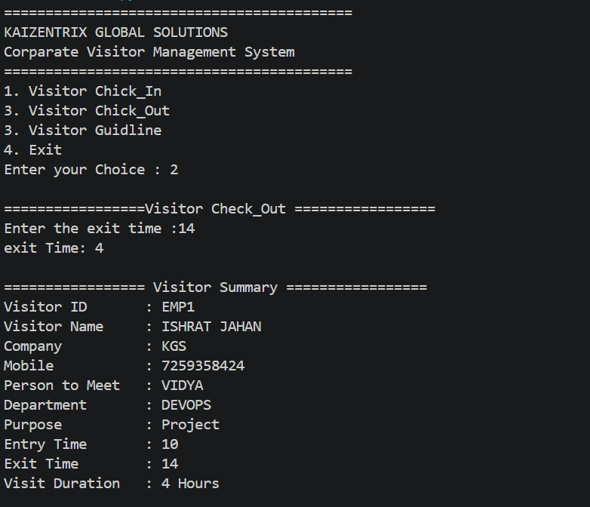

The task demonstrates fundamental Python OOP concepts and basic state-based validation in a menu-driven visitor management program. It successfully prevents duplicate check-in and check-out without check-in, checks same-day exit-time order, and prints a visitor summary. More complete input and time validation can be added in a future version.

